18th April 2016

**FIA WTCC Slovakia brings passion to Motorsports**

*Monteiro wins opening race and leads the Championship

*López manages another victory in the main race

The FIA World Touring Car Championship visited Slovakia at the weekend in what proved an exciting Motorsport weekend, with close to 40,000 spectators and with YOKOHAMA as Official Tyre supplier for both the WTCC and ETCC.

In the big boys league of the World Championship, the opening race was won by Honda Racing’s Thiago Monteiro who chose his moment two laps from the chequered flag to overtake Bennani who had led till then. Monteiro’s patience and continuous pressure on the Moroccan driver eventually paid off. Meanwhile Rob Huff, who returned to winning ways at Paul Ricard a fortnight ago, also pressed as hard as he could and made the podium in third closely following Bennani. In fourth the veteran Tarquini used all his experience and skill to manage keeping Muller and López right behind him across the line. The sour note of the race was a troubled end to Ferenc Ficza’s first WTCC appearance, with his Zengő Motorsport Honda Civic catching fire and having to abandon three laps from the end.

The weight compensation regulation in the opening of the Championship is an opportunity that Honda Racing have done well to capitalise on so far. It remains to be seen, how after the additional 80kgs, Citroen is carrying, is removed how the Championship may turn. In the meantime, Honda is ahead of Citroen in the Manufacturers table by 3 points.

In the main race, Monteiro, who was on P7 also took a podium finishing second to his direct rival José María López which enabled him to keep the championship lead by a single point over “Pechito”. The two times in a row, Argentinian Champion worked hard for his victory and had to contend with a dynamic Nicky Catsburg, who defended his lead until one lap remained.

López had “flown” from P3 to P1 at the start, overtaking Catsburg and team-mate Yvan Muller, who then fell behind to a very fast Catsburg. Following a problem on his car, López had to manage the situation with great care ahead of the speeding Lada Vesta from Catsburg who took the lead on the 4th lap. Catsburg was intent on taking his first WTCC win for the LADA Vesta but Champion López admirably continued attacking, even against the odds, until he was able to overtake on the penultimate lap. In the end Monteiro, who had been following closely also took the better from Catsburg who eventually made it to the last place in the podium.

After the race, López paid tribute to his resilient team and congratulated his opponents for their good job. The Championship will resume at Hungaroring with the WTCC Race of Hungary, 22nd-24th April with all eyes on home favourite Norbert Michelisz, now with Honda.

**Drivers Championship Standings;**

Thiago Monteiro 77pts

Jose Maria López 76pts

Norbert Michelisz 52pts

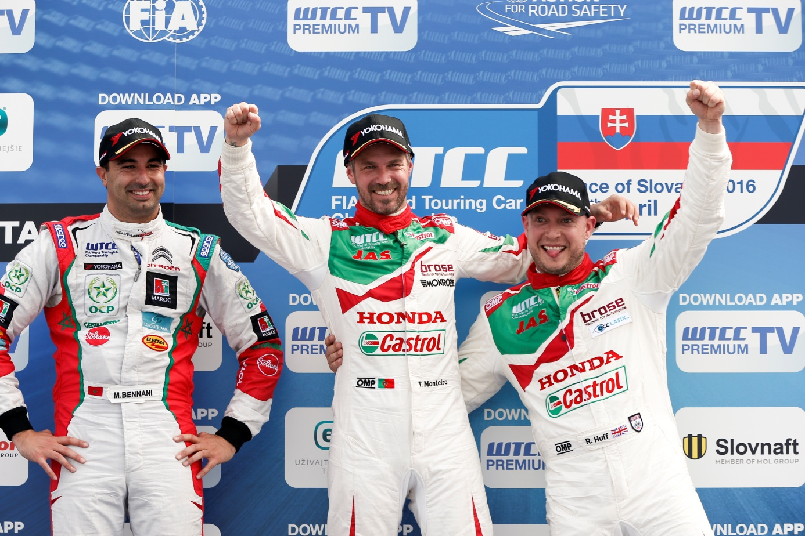

*Happy Honda Team in the Podium at Slovakiaring*

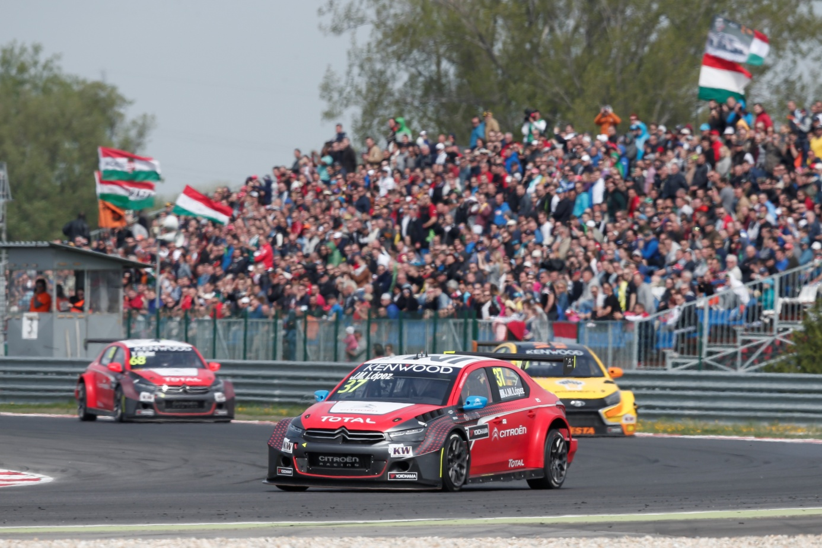

*Lopez Leads ahead of Catsburg in WTCC Slovakia*

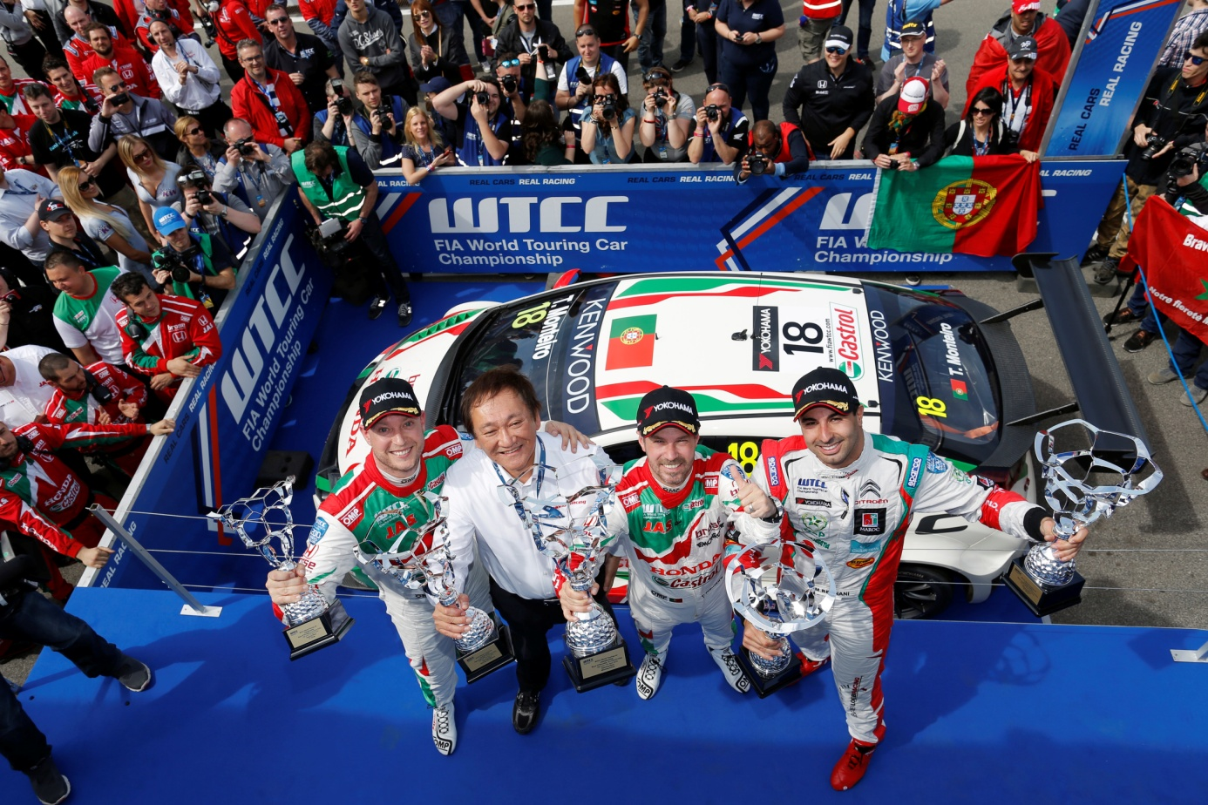

*Monteiro celebrates Opening Race Podium*